GNU Octave, version 3.8.2
Copyright (C) 2014 John W. Eaton and others.
This is free software; see the source code for copying conditions.
There is ABSOLUTELY NO WARRANTY; not even for MERCHANTABILITY or
FITNESS FOR A PARTICULAR PURPOSE. For details, type 'warranty'.

Octave was configured for "x86_64-pc-linux-gnu".

Additional information about Octave is available at http://www.octave.org.

Please contribute if you find this software useful.
For more information, visit http://www.octave.org/get-involved.html

Read http://www.octave.org/bugs.html to learn how to submit bug reports.
For information about changes from previous versions, type 'news'.

a = 1.000000
l = 1.000000
T = 0.200000

ε = 0.000000

n = 10
k = 10
hx = 0.100000
ht = 0.020000

Начальное возмущение =
0.25 * sin(pi * x)

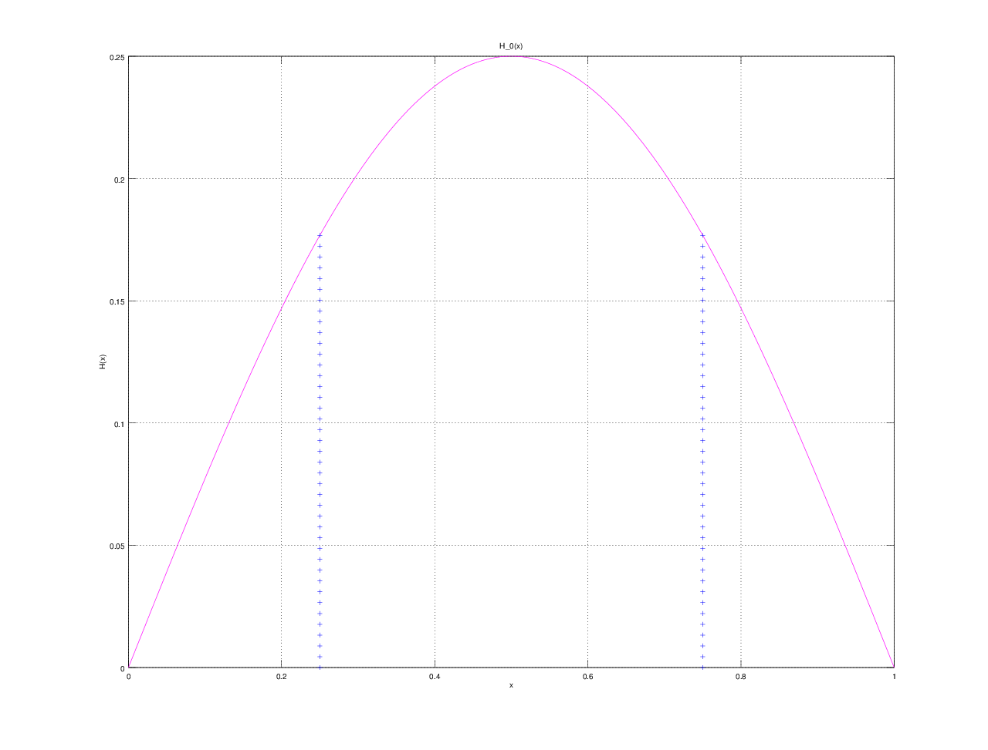

Всего демпферов: 2

Демпфер # 1

x_1 = 0.250000

Верхнее предельное значение w_1(t) =
NaN

Нижнее предельное значение w_1(t) =
NaN

Управляющая функция w_1(t):
5.83895
-13.55896
-33.82044
41.56619
-14.04191
-34.83575
35.70020
36.04293
5.87735
-0.96174
37.08590

Демпфер # 2

x_2 = 0.750000

Верхнее предельное значение w_2(t) =
NaN

Нижнее предельное значение w_2(t) =
NaN

Управляющая функция w_2(t):
0.97438
42.92883
-24.03842
-12.14257
9.02372
27.01451
5.40635
-0.50391
20.04900
-15.76503
13.76377

E(T) =
0.11436

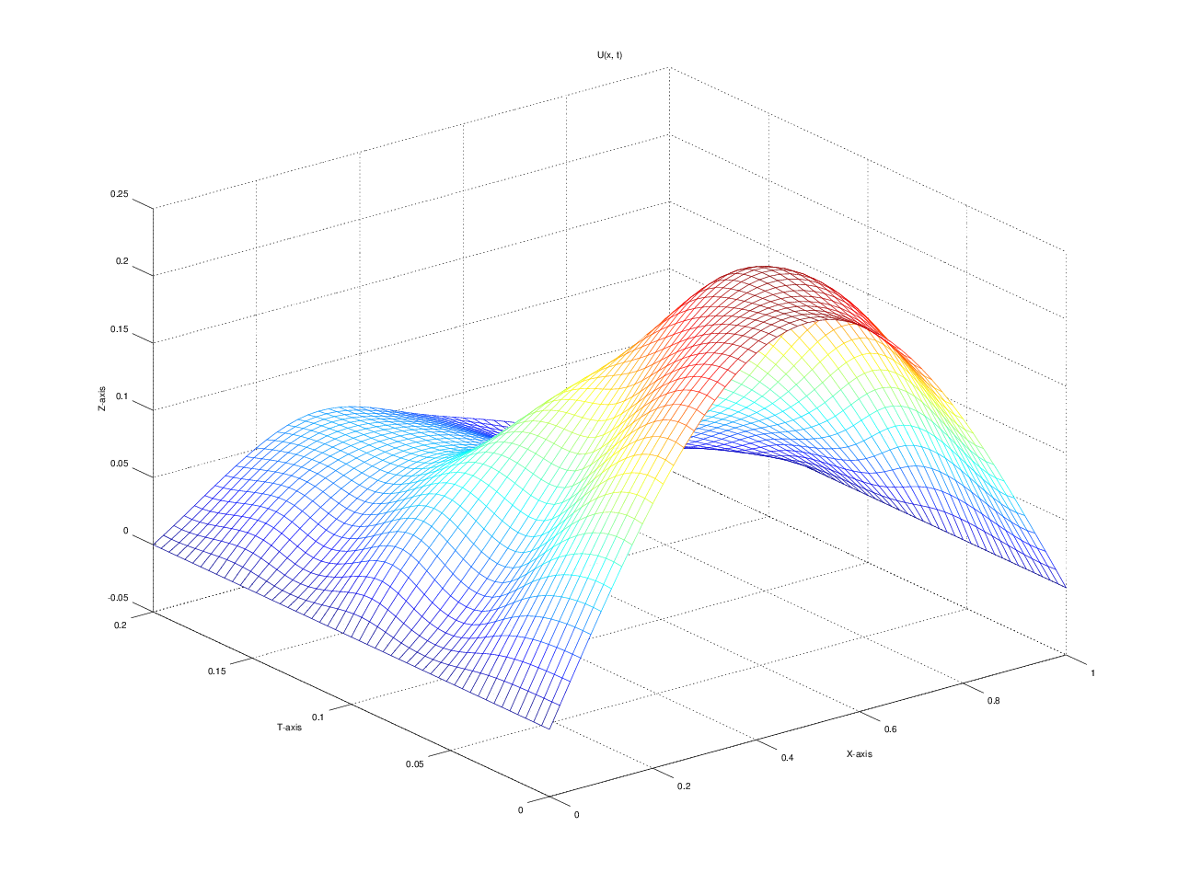

u(x, t)
T = 0.000000: 0.000000 0.077254 0.146946 0.202254 0.237764 0.250000 0.237764 0.202254 0.146946 0.077254 0.000000
T = 0.020000: 0.000000 0.074351 0.141248 0.195399 0.231944 0.247081 0.240548 0.212607 0.158455 0.082955 0.000000
T = 0.040000: 0.000000 0.058618 0.112467 0.164545 0.211108 0.240812 0.247965 0.226786 0.174709 0.095474 0.000000
T = 0.060000: 0.000000 0.036133 0.080911 0.132039 0.183228 0.224175 0.236766 0.212915 0.161787 0.089670 0.000000
T = 0.080000: 0.000000 0.039439 0.084525 0.129232 0.164723 0.185732 0.187581 0.167434 0.122728 0.062297 0.000000
T = 0.100000: 0.000000 0.054558 0.092650 0.120286 0.137902 0.138269 0.129108 0.113447 0.085811 0.045764 0.000000
T = 0.120000: 0.000000 0.041057 0.075502 0.092063 0.094693 0.094374 0.087990 0.076399 0.059839 0.034355 0.000000
T = 0.140000: 0.000000 0.029587 0.059439 0.074636 0.070597 0.061860 0.057094 0.050335 0.035138 0.016084 0.000000
T = 0.160000: 0.000000 0.038213 0.061594 0.070250 0.066990 0.053154 0.035424 0.021970 0.013314 0.006646 0.000000
T = 0.180000: 0.000000 0.033745 0.059811 0.068919 0.063405 0.049787 0.029744 0.011276 0.002167 0.000085 0.000000
T = 0.200000: 0.000000 0.026045 0.050960 0.065097 0.060479 0.045234 0.031169 0.017149 0.003011 -0.003265 0.000000
GNU Octave, version 3.8.2
Copyright (C) 2014 John W. Eaton and others.
This is free software; see the source code for copying conditions.
There is ABSOLUTELY NO WARRANTY; not even for MERCHANTABILITY or
FITNESS FOR A PARTICULAR PURPOSE. For details, type 'warranty'.

Octave was configured for "x86_64-pc-linux-gnu".

Additional information about Octave is available at http://www.octave.org.

Please contribute if you find this software useful.
For more information, visit http://www.octave.org/get-involved.html

Read http://www.octave.org/bugs.html to learn how to submit bug reports.
For information about changes from previous versions, type 'news'.

a = 1.000000
l = 1.000000
T = 0.200000

ε = 0.000000

n = 10
k = 10
hx = 0.100000
ht = 0.020000

Начальное возмущение =
0.25 * sin(pi * x)

Всего демпферов: 2

Демпфер # 1

x_1 = 0.250000

Верхнее предельное значение w_1(t) =
NaN

Нижнее предельное значение w_1(t) =
NaN

Управляющая функция w_1(t):
-15.927
-27.642
-13.240
31.802
-13.705
-14.422
24.194
25.532
12.873
-11.758
28.153

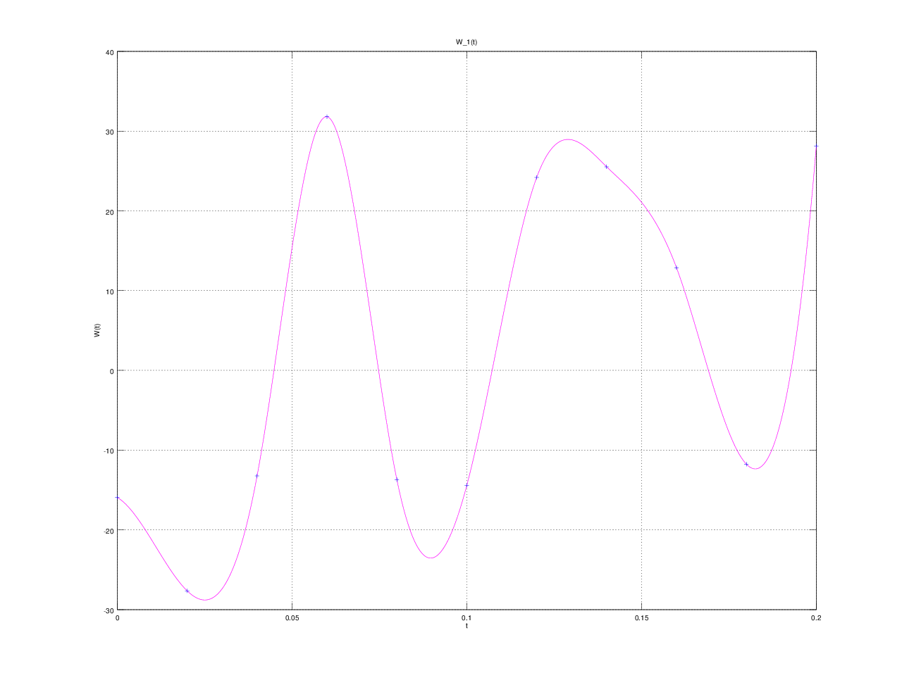

Демпфер # 2

x_2 = 0.750000

Верхнее предельное значение w_2(t) =
NaN

Нижнее предельное значение w_2(t) =
NaN

Управляющая функция w_2(t):
-12.0569
36.5270
-22.7359
-24.3947
12.4392
39.5531
13.1716
-7.7398
23.1859
-14.1197
10.2494

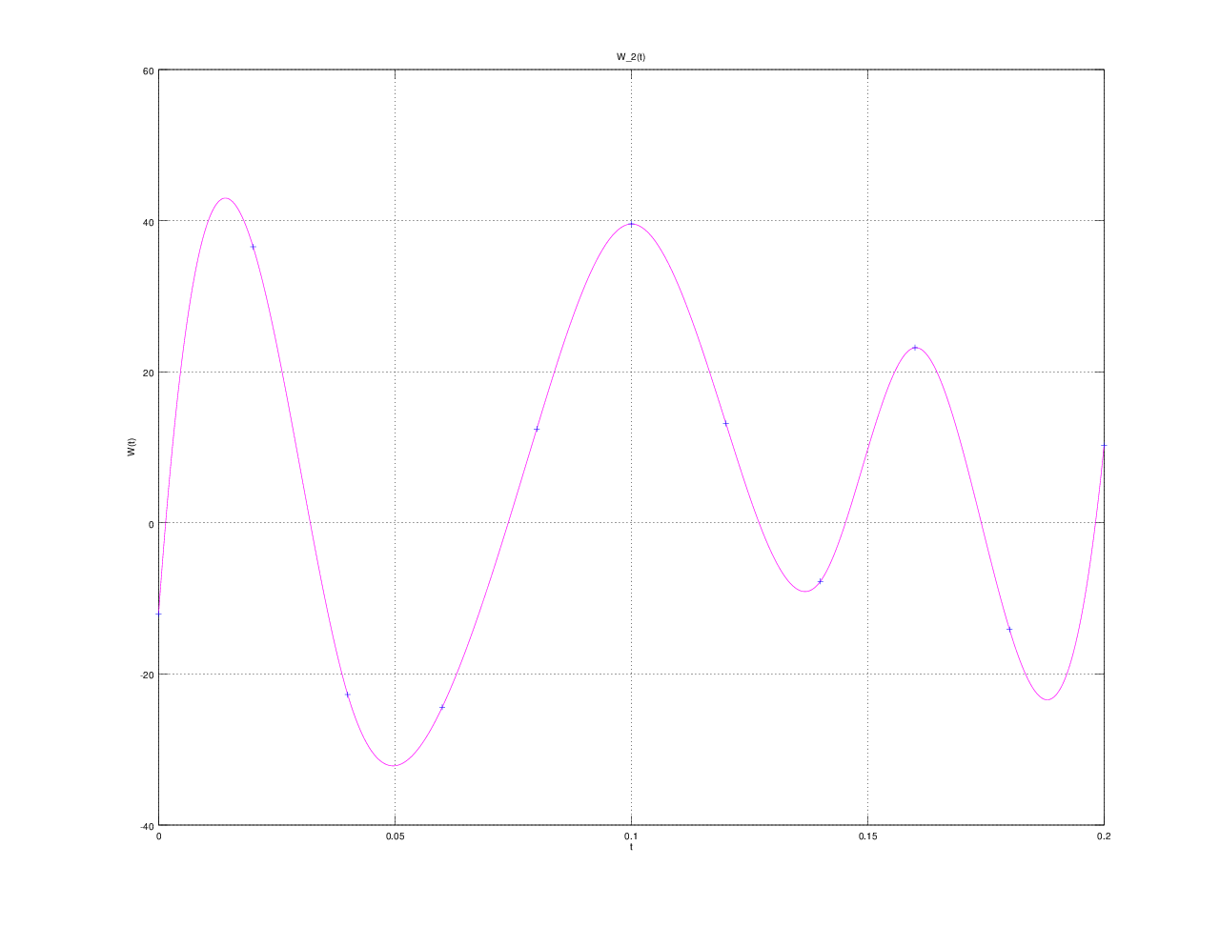
E(T) =
1.0887e-09

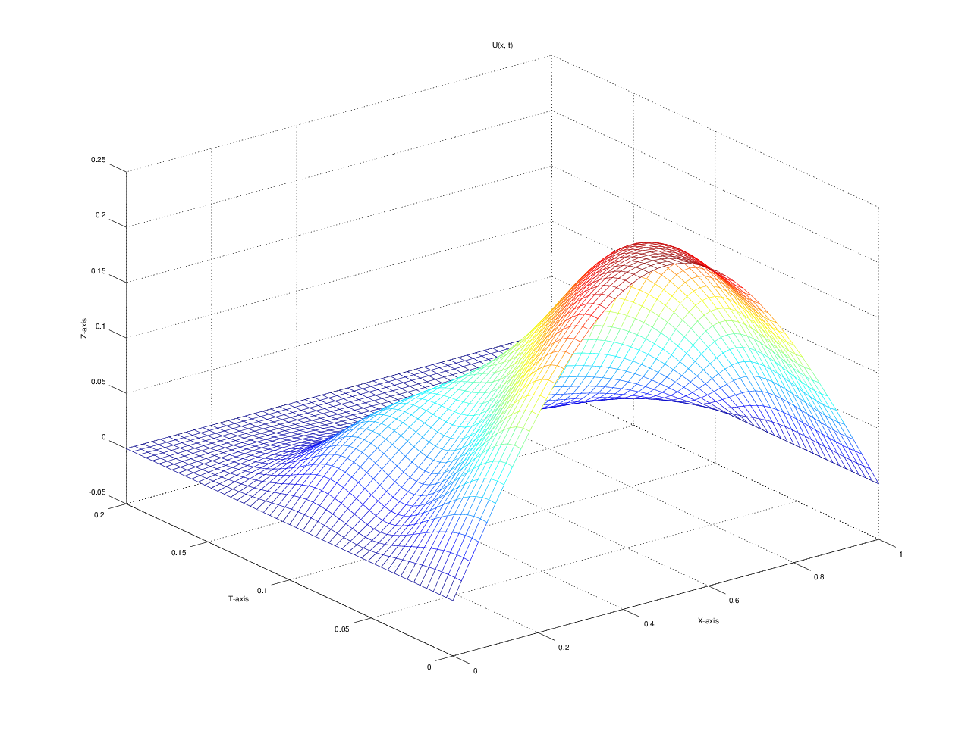

u(x, t)
T = 0.000000: 0.000000 0.077254 0.146946 0.202254 0.237764 0.250000 0.237764 0.202254 0.146946 0.077254 0.000000
T = 0.020000: 0.000000 0.068606 0.129812 0.184126 0.226000 0.244290 0.237340 0.206806 0.152491 0.079945 0.000000
T = 0.040000: 0.000000 0.043586 0.089633 0.140415 0.189733 0.223997 0.232865 0.211558 0.160776 0.086718 0.000000
T = 0.060000: 0.000000 0.026111 0.062740 0.105325 0.147865 0.184952 0.200792 0.183911 0.141325 0.079038 0.000000
T = 0.080000: 0.000000 0.035756 0.068128 0.096958 0.119492 0.130779 0.129898 0.116860 0.088030 0.046163 0.000000
T = 0.100000: 0.000000 0.042658 0.072009 0.086118 0.086179 0.074634 0.061195 0.051366 0.037256 0.017673 0.000000
T = 0.120000: 0.000000 0.028103 0.049792 0.054140 0.043479 0.031799 0.023905 0.018782 0.014434 0.008528 0.000000
T = 0.140000: 0.000000 0.012472 0.021357 0.021799 0.015264 0.008766 0.005930 0.006433 0.005990 0.003138 0.000000
T = 0.160000: 0.000000 0.004849 0.008312 0.008045 0.004479 0.000763 -0.001421 -0.001703 -0.001436 -0.001051 0.000000
T = 0.180000: 0.000000 0.001177 0.002169 0.002023 0.000778 -0.000488 -0.001454 -0.001979 -0.001833 -0.001055 0.000000
T = 0.200000: 0.000000 0.000002 0.000003 -0.000002 0.000003 -0.000005 0.000004 -0.000002 0.000003 0.000002 0.000000

